**Basic Service Set (BSS) and Extended Service Set (ESS) in Wi-Fi Networks**

**Service Set in Wi-Fi Networks**

A **Service Set** refers to a group of **wireless devices (clients and access points) that share a common network configuration** in a Wi-Fi environment. It defines how devices communicate within a Wi-Fi network and is classified into different types based on network architecture.

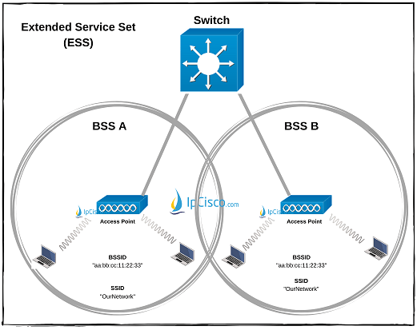

1. **Basic Service Set (BSS):**

A **Basic Service Set (BSS)** is the **fundamental building block** of a Wi-Fi network. It consists of:

* **One Access Point (AP)** (or none in the case of an ad-hoc network).
* **Multiple Wireless Clients (Stations, STAs)** that communicate with the AP.

Each BSS has a **unique identifier** called the **Basic Service Set Identifier (BSSID)**, which is typically the **MAC address of the AP**.

#### ****Types of BSS:****

1. **Infrastructure BSS** – Uses an AP to connect wireless clients to a wired network.
2. **Independent BSS (IBSS)** – Also called an ad-hoc network, where devices communicate **directly** without an AP.

#### ****Limitations of BSS:****

* Devices in one BSS cannot communicate with devices in another BSS unless an **additional network infrastructure** is in place.
* The coverage area is **limited** to the range of a single AP.

### ****Extended Service Set (ESS):****

An **Extended Service Set (ESS)** is a **collection of multiple BSSs** interconnected to form a **larger Wi-Fi network**. It consists of:

* **Multiple APs** connected via a wired **distribution system (DS)** (e.g., Ethernet switch).
* **Wireless Clients (STAs)** that can **roam between APs** without losing connectivity.

Each ESS is identified by a **Service Set Identifier (SSID)**, which is the **network name visible to users**.

#### ****Advantages of ESS:****

* **Seamless Roaming** – Devices can move between APs without dropping connections.
* **Extended Coverage** – Provides Wi-Fi access across larger areas.
* **Load Balancing** – Distributes clients among multiple APs for better performance.

**How Seamless Roaming Works in an Extended Service Set (ESS)?**

In an **Extended Service Set (ESS)**, multiple **Access Points (APs)** work together to provide **continuous Wi-Fi coverage**. When a device moves from one AP’s coverage area to another, it switches to the stronger AP **without losing connection**. This process is called **Wi-Fi roaming**, and it happens through several mechanisms.

**1. Understanding Roaming in ESS**

Each AP in an ESS:

* Shares the **same SSID** (network name) so devices don’t see multiple networks.
* Has a **different BSSID** (MAC address of the AP).
* Is connected through a **wired distribution system (like Ethernet and switches)**.

A wireless client (STA) **monitors signal strength** and automatically switches to the strongest AP when moving.

**2. Steps in Seamless Roaming**

1. **Signal Monitoring:**

* The client device constantly measures the **Received Signal Strength Indicator (RSSI)** of its connected AP.
* If the **signal drops below a threshold**, the device starts scanning for a **stronger AP**.

1. **Scanning for New APs:**

* The client sends **probe requests** to nearby APs.
* APs respond with **probe responses**, giving details like signal strength and supported speeds.

1. **Deciding the Best AP:**

* The client **compares RSSI values** and picks the strongest AP.
* If a better AP is found, it begins the transition process.

1. **Re-authentication & Handoff:**

* The client **disconnects from the old AP** and **associates with the new AP**.
* In enterprise networks, **fast roaming protocols (802.11r, 802.11k, 802.11v)** speed up this process.
* If WPA2/WPA3 security is used, **pre-authentication** ensures a quick switch.

1. **IP Address Continuity (Same Network Subnet):**

* The new AP keeps the same **IP address** assigned by the router.
* This prevents interruptions in ongoing activities like video calls or downloads.